**Ideation Phase**

**Define the Problem Statements**

|  |  |
| --- | --- |
| Date | 19 September 2022 |
| Team ID | PNT2022TMID28921 |
| Project Name | WEB PHISHING DETECTION |
| Maximum Marks | 2 Marks |

**Customer Problem Statement:**

A user while using the internet gets redirected to malicious websites via phishing links using various sources such as emails, links through messages, advertisement links,malicious links etc. Phishing is the attempt made to steal the users personal information .The user gets frustrated because of this and hates to browse through the internet.So we need a method to overcome this intrusion to prevent many more victims of web phishing.

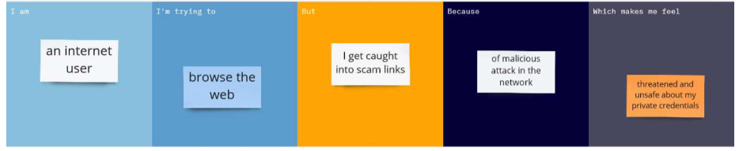

|  |  |  |  |  |  |
| --- | --- | --- | --- | --- | --- |
| **Problem Statement (PS)** | **I am (Customer)** | **I’m trying to** | **But** | **Because** | **Which makes me feel** |
| PS-1 | Internet user | Browse the internet | Determine a fraud | An attacker steals my information | Unsafe about my information shared over a network |
| PS-2 | Email user | Open and work on emails | Detect a malicious email | They are not authorized and looks suspicious | My emails are under a thirdparty intrusion |